**Chapter 8 – Team Project - Implementing Security Features for the Team Project**

**Step 8.1 – Design a value-independent view that hides some sensitive/private information. Then create the value-independent view in the database.**

**--Create a value-independent view For Employee as “PublicEmployee” that hides sensitive information:  
**

**-- Query the PublicEmployee view**

**Step 8.2 - Create a user and authorize that person to read the view. Connect to the database as the new user and demonstrate (provide screenshots) that the new user can read the view. Draw an authorization graph using a drawing tool, showing the privileges given.**

**Login Database as SYS:**

1. **Create a User and Authorize Reading the View:  
   A screen shot of a computer

   Description automatically generated**
2. **Connect to the Database as the New User:**

1. **Demonstrate Read Access:**

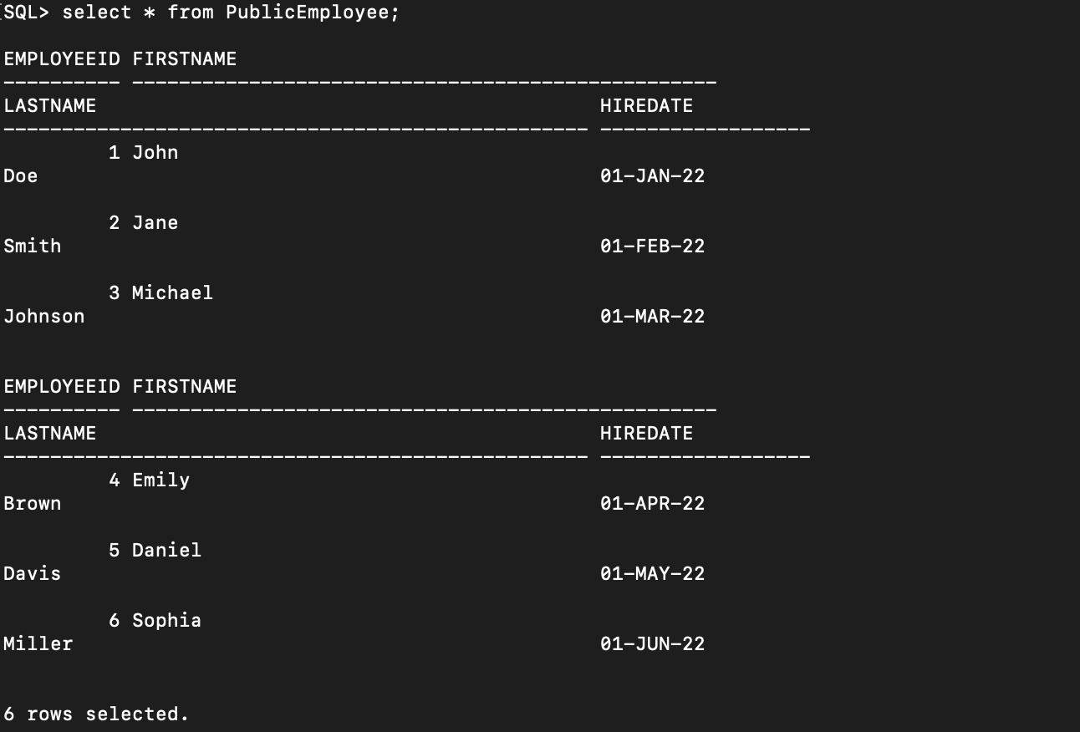

1. **Authorization Graph:**

**Step 8.3 – Create and authorize four other users to access/modify different parts of the database. For each new user, connect to the database and demonstrate (provide screenshots) that each new user can access/modify the different parts of the database that you granted. Update the authorization graph using a drawing tool, showing the privileges given.  
1. Create four new users**

**2. Grant different privileges to each user**

**3. Connect Users:**

**USER1:**

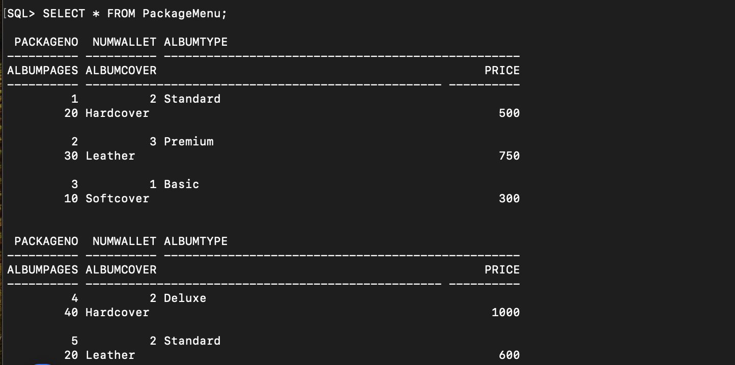

**USER4:**

**SELECT**

**INSERT:**



**UPDATE:**

**DELETE:**

**You can see there is no contract no 1028 after contract no 5.**

**4. Authorization Graph:**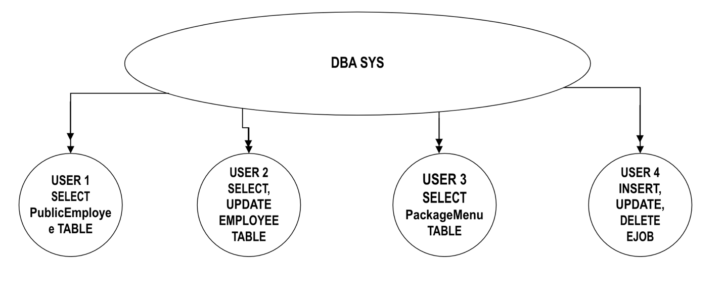

**Step 8.4 - Design an audit trail trigger for updates to a sensitive/private item. Then create the audit trail trigger in the database.**

1. **Create an Audit Table:**

1. **Create the Audit Trail Trigger:**

1. **Test the trigger:**

**Performing an update on the Salary column to test the trigger:**

**Step 8.5 – Design and execute SQL statements to demonstrate that the trigger is working as expected.**

**In Above screenshot:**

**Here Firstly, we updated salary from 50000.00(old-salary) to 60000.00(new-salary).**

**Here Secondly, we updated again salary from 60000.00(old-salary) to 65000.00(new-salary).**